
PURBANCHAL UNIVERSITY
Faculty of Science & Technology
Biratnagar, Nepal

HIMALAYAN WHITEHOUSE INT’L COLLEGE
Graduate School of IT & Engineering
Khumaltar, Lalitpur

Final Year Project Report
On
COLLEGE INFROMATION MANAGEMENT
SYSTEM (CIMS)

By
Gopal Gautam (Symbol No. 380533)
Niroj Kumar Shrestha (Symbol No. 380536)
November, 2015

Student’s Declaration

We hereby declare that the project report entitled
College Information Management System (CIMS)
Submitted in partial fulfillment of the requirement for the degree of
Bachelor in Computer Engineering

To
Purbanchal University, Biratnagar, Nepal

Is our original work and not submitted for the award of any other degree,
diploma, fellowship or any other similar title or prizes.

Name of Student Registration No. Symbol No.
Gopal Gautam 034-32-07745-2010 380533
Niroj Kumar Shrestha 034-32-07749-2010 380536

Date: November, 2015

Letter of Recommendation

I certify that Mr. Gopal Gautam and Mr. Niroj Kumar Shrestha have prepared this project work under my supervision and guidance as a partial fulfillment of the requirements for the Bachelor in Computer Engineering (BE Computer), Purbanchal University.

I recommend this project work for examination and acceptance.

………………………………………..
Mr. Sudhir Shrestha
Project Supervisor
November, 2015

BONAFIDE CERTIFICATE

THIS IS TO CERTIFY THAT THE PROJECT ENTITLED
“COLLEGE INFORMATION MANAGEMENT SYSTEM”
Being submitted to the Purbanchal University, Biratnagar
By
GOPAL GAUTAM
NIROJ KUMAR SHRESTHA
As a partial fulfillment for the award of degree of Bachelor in Computer Engineering, is the bonafide work carried out by them, under my guidance and supervision.
………………………………………… ……………………………...
Mr. Kushal Niroula Er. Ishwar Dhungana Coordinator External Examiner
Dept. of IT & Engineering
Himalayan WhiteHouse Int’l College
…………………………………….. …………………………….. Mr. Sudhir Shrestha Official Stamp
Project Supervisor Himalayan WhiteHouse Int’l College Himalayan WhiteHouse Int’l College November, 2015
To whom it may concern

Acknowledgement

First and foremost, we would like to thank God for blessing us with the strength, intelligence and patience to complete this project.
We must acknowledge our deep sense of gratitude to all the people who have made contributions to inspire us for doing such a creative work of CIMS. It is really hard to thank everybody but a few people need special mentions.
We are grateful again first and foremost to our department coordinator, Kushal Niroula, for making us inspires to do great things from our hidden knowledge and for helping us in every step of our project.
Thank you Mr. Sudhir Shrestha , as project supervisor, for your advice throughout the project and kind support for every step of our project till the end.
Similarly, we would like to thank all the teachers and staff members of our college ‘Himalayan WhiteHouse Int’l College’.
And our heartfelt gratitude to our families, friends and countless users who will use this program. We welcome constructive comments and suggestions from all, which will help us to do even better.
Thank you!!

Gopal Gautam 380533
Niroj Kumar Shrestha 380536

Abstract

Our project “COLLEGE INFROMATION MANAGEMENT SYSTEM” provides organized view and notifications with full user interface for all staffs and students about all the activities and functionalities of the college. Additional to it, it keeps record of all the staffs and students along with overall processes of college. It enhances the sequential view of the database records and allows various functions according to the permissions granted to the user.
Our project is a web application that provides login interface to the users to reach own profile and gives full function as per the permissions invoked. Only the valid user i.e. staffs and students, who are registered by the super admin, can login with their username and password. One can create, modify, delete and view the records with the bound of permissions granted and can have full information. Logged in users will receive the updates like notice, exam routine, daily class routine, notes, results, messages and all information connected to them or their groups. Every user is assigned to at least a group and they can create their own group as well. All the student records, staff records and college information are stored in database which can be viewed by the user as per their eligibility provided by super admin.

List of Figures
Figure 1: MVC ………………………………………………………………Page No. 2
Figure 2: MVC ………………………………………………………………Page No. 2
Figure 3: MVC ………………………………………………………………Page No. 2
Figure 4: MVC ………………………………………………………………Page No. 2
Figure 5: MVC ………………………………………………………………Page No. 2
Figure 6: MVC ………………………………………………………………Page No. 2
Figure 7: MVC ………………………………………………………………Page No. 2
Figure 8: MVC ………………………………………………………………Page No. 2
Figure 9: MVC ………………………………………………………………Page No. 2
Figure 10: MVC ………………………………………………………………Page No. 2

List of Tables (if..)
Table 1: Figure Title …………………………………………………………………Page No.

List of Abbreviations
CIMS - College Information Management System
VS - Visual Studio
IIS - Internet Information Service
AJAX - Asynchronous JavaScript and XML
SDLC - System Development Life Cycle
OOP - Object Oriented language
HTTP - Hypertext Transfer Protocol
HTTPS - Hypertext Transfer Protocol Secure
FTP - File Transfer Protocol
FTPS - File Transfer Protocol over Secure Sockets Layer
SMTP - Send Mail Transfer Protocol
NNTP - Network New Transfer Protocol
WPF - Windows Presentation Foundation
WCF - Windows Communication Foundation
WF - Workflow Foundation
WinRT - Windows Runtime
ALM - Application Lifecycle Management
XAML - Extensible Application Markup Language
UI - User Interface
API - Application Programming Interface
MVC - Model-View-Controller
ASP - Active Server Pages
iOS - iphone Operating System
CLR - Common Language Runtime
XML - Extensible Markup Language
XSLT - Extensible Stylesheet Language Transformations
HTML - Hypertext Markup Language
XHTML - Extensible Hypertext Markup Language
CSS - Cascading Style Sheets
ECMA - European Computer Manufacturers Association
ISO - International Organization for Standardization
SQL - Structured Query Language
ANSI - American National Standards Institute
NT - New Technology
CMYK - Cyan, Magenta, Yellow and key (black)
PSD - Photoshop Document
PSB - Photoshop Big

Table of Contents
Acknowledgement ………………………………………………………………….…………. i
Abstract …………….……………………………………………………………….…………. ii
List of Figures ……………………………………………………………………….………... iii
List of Tables ………………………………………………………………………………..... iv
List of Abbreviations ………………………………………………………………………….. v
CHAPTER 1: Introduction …………………………………………………………………… 1
  - Background & Significance………………………………………………………. 1
  - Problem Statement ……………………………………………………………... 2
  - Rationale of the Project……………………………………………………… 3
  - Objective…………………………………………………………….... 4
CHAPTER 2: Literature Review ………………………………………………………………
  - Microsoft Visual Studio 2013
  - .NET Framework 4.0
  - ASP.NET MVC 5
  - Microsoft Visual C#
  - Microsoft SQL Server
  - IIS
  - JavaScript
  - Bootstrap with HTML5 and CSS3
  - AJAX
  - Adobe Photoshop
  - Microsoft Visio 2013
CHAPTER 3: System Development Concept

CHAPTER 4: Feasibility Study and Requirement Analysis
CHAPTER 5: System Planning and Design
(Sub Chapters: Algorithm, Flow-Chart, DFD up to 2 level, ER-Diagram, Data Model, Process Diagram, Class Diagram, Use-Case Diagram Pseudo-code)
CHAPTER 6: System Development
(Main code modules)
CHAPTER 7: System Integration & Testing
(Sub Chapters: Testing environment, Error Checking, Interoperability.)

CHAPTER 8: Implementation
CHAPTER 9: Limitations & Maintenance
CHAPTER 10: Conclusion
CHAPTER 11: References
Appendix
Snapshots

CHAPTER 1: INTRODUCTION
  - Background
With the drastic flourishment of software world, need of application is also augmented in every sector of mankind. So, organized view and storage has been the first concern. Same is the case in educational sector as well. There is inconveniency in processing the educational institute or college information among students, teachers, & managerial staffs visiting individual doorsteps. With the normal non-electronic information flow, there can’t be proper relationships and unity among the students, teachers and managerial staffs. In present scenario, sharing of proper education materials, notes, resources, assignments, etc. without electronic flow is very much difficult and inefficient.
These present status of educational institution led us to point out the idea and develop our project “College Information Management System”. CIMS can engulf all the problems above with the additional features of messages, resources, routines and so on. With the login mechanism and permission granting to each users, system is secured and organized as well. CIMS enables to get records of all faculty members, staffs and students and to give full mobilization to the resources and messages. There is also the provision for routine and subject assignment. Each user has to login and there is separate profile for all. The unnecessary job to occupy whole day for result distribution and suggestions can be easily done with the notifications through our application.
CIMS is a web application developed to nullify the problems of educational institutes and to establish new and fast trend of educational flows for easy and organized view, and overall processing in that institution or college.
  - Problem Statement
With our research for the project, we found a web based application, Fedena, which is also multipurpose school management software and student information system. It allows different functionality but still lacks the proper information flow, routine assignment and sharing resources. There are number of problems still present in educational institute which are unrecognized or ignored if recognized. In this information age also, if information can’t be mobilized or managed in electronic fast way, especially in colleges, it directly indicates the lagging phase of education system.
Still lots of ideas and solutions to the problems in the mind of staffs and students, there is no sharing media to uplift the overall academic performance. Processing the ideas only in college time and then setting meeting and only implementing after evaluation is a long, unnecessary and time waste mechanism.
The only solution to all these problems is CIMS.
CIMS not only organized the management sector of colleges but also provides full communication and proper information and idea flow among all college family. Along with it, it can be used from anywhere anytime with complete notifications of updated records.
  - Rationale of the project
There is a huge gap between the teachers, managerial staffs and the students in the academic field. This leads to the lack of proper relationship among them and overall low academic performance. This is never the goal of educational institutes or colleges. Similarly, poor information flow among the students, teachers and staffs ultimately reduces the quality of the education. The performance of every college staffs and students will be slow and negative if they can’t communicate with each other in user interface electronic media. Every college still lack these problems. Again, reaching every classes for notifying students and visiting every managerial staffs’ doorstep is time legacy and vigorous way of education system. Making individual mark sheet for all students in small exams like in unit test or internal assignment is difficult, time consuming and neglecting part in academic institution.
As, there are lots of unnoticeable but needed factors in education system, which are still ignored. In this scenario, the need of CIMS can be listed as below:
- Poor information flow between the students, teachers and managerial staffs ultimately reduces the quality of the education.
- Collecting information regarding various academic works and notices via visiting every Managerial staffs’ doorstep is a sluggish nature of education system.
- Sharing of proper education matters, notes assignment through non-electronic media is inconvenient.
- Non unity among the College Managerial team, the Teachers and the Students can be discarded.
- Proper solution of the issues regarding students, teachers and staffs need a group discussion with liberty though.
  - Objectives
With the research of the problems and issues in educational system, side by side major objectives that are considered with principal idea of CIMS are as follows:
- To establish a smooth informative relationship between the various entities of Colleges
- To minimize the overheads caused due to inefficiency of various resource sharing between the various authorized college bodies, the Tutor and the students
- To maintain a proper profile based information of the students and the staffs
- To create a user-friendly environment of proper flow of information like notices, schedules etc.
- To create a spirit of unity within the college premises and its various bodies.

CHAPTER 2: LITERATURE REVIEW
2.1 Microsoft Visual Studio 2013
Microsoft Visual Studio is the default development environment for developing Windows applications, ranging from traditional WinForms to the latest WinRT creations. VS 2013 offers performance analysis for XAML UI Responsiveness among other metrics. VS 2013 also supports Office 365 Cloud Business application development. With rumors swirling that a fully implemented Microsoft Office suite will one day make it to Android and iOS platforms, this technology has tantalizing possibilities for easy Office-centric ALM across a variety of mobile platforms. Web development is another area where VS2013 has made ample improvements. ASP.NET developers will be pleased to discover that they can comfortably mix and match whatever framework they prefer (MVC, Web API, WebForms) in the same project.
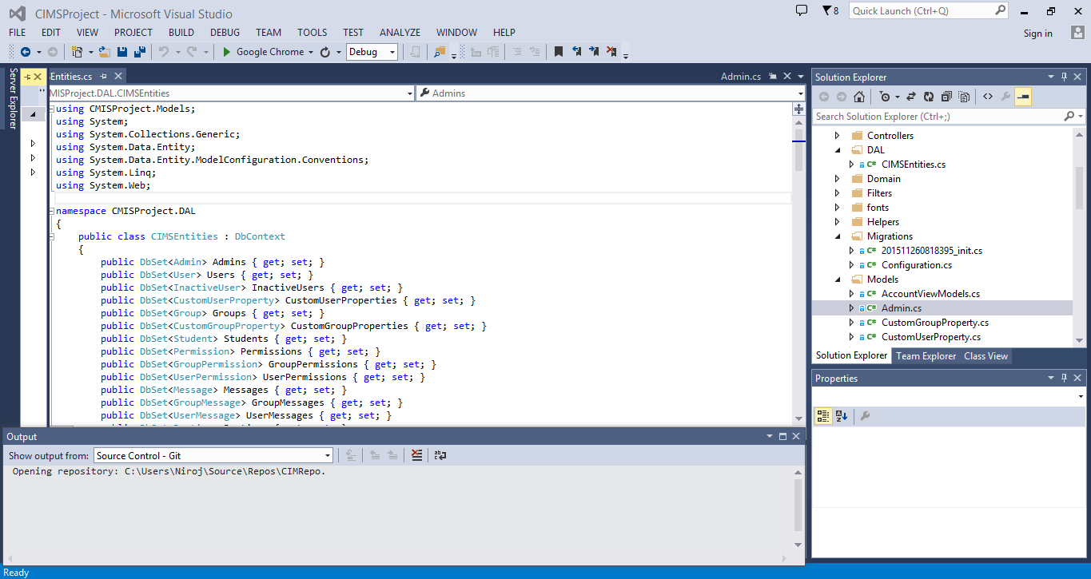
Fig 2.1: Microsoft Visual Studio Professional 2013
It includes a code editor supporting IntelliSense as well as code refactoring. The integrated debugger works both as a source-level debugger and as a machine-level debugger. It supports languages by means of languages services, which allow the code editor and debugger to support nearly any programing language, provided a language specific service exists. Built-in languages include C/C++ (via Visual C++), VB.Net (via Visual Basic.Net), J# and C# (via Visual C#). It also supports XML/XSLT, HTML/XHTML, Java Script and CSS. It allows File System Support, Local IIS Support and FTP Support.
2.2 .Net Framework 4.0
The .Net Framework is the infrastructure for the Microsoft .Net platform, specially designed to make working with the Internet easy. It includes a large library of coded solutions to common programming problems and a virtual machine that manages the execution of programs written specifically for the framework. At the base of the .Net Framework is the Common Language Runtime (CLR).

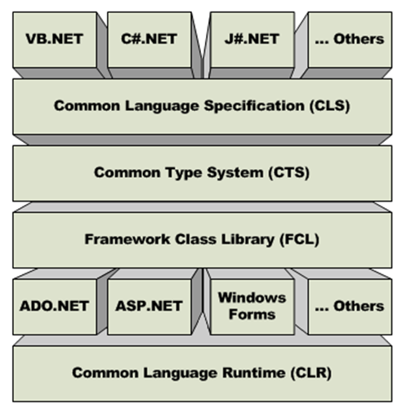
Fig 2.2: .Net Framework

The current track of Microsoft development has three major verticals for certifications; they are:
- Windows Store Apps
- Web Applications
- ALM (Application Lifecycle Management)
Additionally, .Net is found going strong in:
- Languages: Microsoft has spent a lot in two languages - C# and XAML. No matter if you develop a Windows Phone app, Windows 8 app, ASP.NET web application, a service, or Windows thick clients, you can use these two languages.
- WCF: Either you build large enterprise applications or mobile applications, Windows Communication Foundation (WCF) has become an industry standard to build distributed applications.
The following are the new features of .NET Framework 4.0:
- Improved Application Compatibility and Deployment Support
- Dynamic Language Runtime
- Managed Extensibility Framework
- Parallel Programming framework
- Improved Security Model
- Networking Improvements
- Improved Core ASP.NET Services
- Improvements in WPF 4
- Improved Entity Framework (EF)
- Integration between WCF and WF
2.3 ASP.Net MVC 5
ASP.NET is a server side scripting technology that enables scripts (embedded in web pages) to be executed by an Internet Server. It is a development framework for building web pages and web sites with HTML, CSS, JavaScript and server scripting. ASP.NET has better language support, a large set of user controls, XML-based components, and integrated user authentication. ASP.NET pages have the extension .aspx, and are normally written in VB (Visual Basic) or C# (C sharp). This project is written in C#.
When a browser requests an ASP.NET file, the ASP.NET engine reads the file, compiles and executes the scripts in the file, and returns the result to the browser as plain HTML.
ASP.NET supports three different development models: Web Pages, MVC (Model View Controller), and Web Forms.
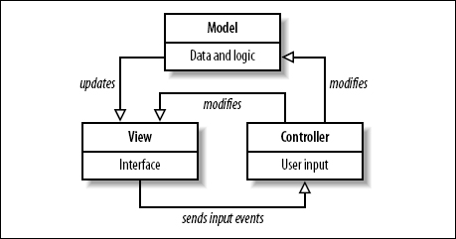
Fig 2.3: MVC model
The Model is the part of the application that handles the logic for the application data.
Often model objects retrieve data (and store data) from a database.
The View is the parts of the application that handles the display of the data.
Most often the views are created from the model data.
The Controller is the part of the application that handles user interaction.
Typically controllers read data from a view, control user input, and send input data to the model.
Additional to all above, ASP.Net easily works with ADO.Net using data binding and page formatting features and also supports Bootstrap. Its application run faster and counters large volume of user without performance problems.
2.4 Microsoft Visual C#
Microsoft Visual C# is Microsoft’s implementation of the C# programming language specification included in the Microsoft Visual Studio suite of products. It is based on the ECMA/ISO specification of the C# language, which Microsoft also created. Microsoft Visual C# is a programming environment used to create graphical user interface applications for the Microsoft Windows family for operating systems. It usually ships either by itself or as part of Microsoft Visual Studio. In most contexts, an unqualified reference to C# is taken to mean Visual C#.
Simply, C# (pronounced "C sharp") is a simple, modern, object-oriented, and type-safe programming language. C# combines the high productivity of Rapid Application Development (RAD) languages and the raw power of C++. Visual C# .NET is Microsoft's C# development tool. It includes an interactive development environment, visual designers for building Windows and Web applications, a compiler, and a debugger.
Creating programs in a C# is a snap. The language is powerful and easy to learn, and the Visual Studio IDE does a lot of work for us automatically. We can leave mundane coding tasks to the IDE and focus on what our code should accomplish.
2.5 Microsoft SQL Server
Microsoft SQL Server is a relational model database server produced by Microsoft. Its primary query languages are Transact-SQL, an implementation of the ANSI/ISO standard structured Query Language used by both Microsoft and Sybase. SQL Server is commonly used by business for small to medium-sized databases, but he past five years have seen greater adoption of the product for larger enterprise databases.
The current version of the SQL Server is SQL Server. It aims to make data management self-tuning, self-organizing, and self-maintaining with the development of SQL Server always on technologies, to provide near-zero downtime. It also includes support for structured and semi-structured data, including digital media formats for pictures, audio, video and other multimedia data.
2.6 IIS
Internet Information Services is a set of Internet-based services for servers using Microsoft Windows. It is an extensible web server created by Microsoft for use with Windows NT family. It supports HTTP, HTTPS, FTP, FTPS, SMTP and NNTP. It has been an integral part of the Windows NT family since Windows NT 4.0. It allows Anonymous authentication that we used in our project for extra security.
2.7 JavaScript
JavaScript is a trademark of Sun Microsystems. It was used under license for technology invented and implemented by Netscape Communications and current entities such as Mozilla Foundation.
JavaScript is an object-oriented scripting language used to enable programmatic access to computational objects within a host environment. Although, also used in other applications, it is primarily used in the form of client-side. JavaScript is implemented as part of a web browser, providing enhanced user interfaces and dynamic websites. JavaScript is a dialect of the ECMA Script Standard and is characterized as a dynamic, weakly typed, prototype-based language with first-class functions. JavaScript was influenced by many languages and was designed to look like Java, but to be easier for non-programmers to work with.
The primary use of JavaScript is to write functions that are embedded in or included form HTML pages and interact with the Document Object Model of the page. Some simple examples of this usages are:
- Opening or popping up a new window with programmatic control over the size, position, and attributes of the new window (e.g. whether the menus, toolbars, etc. are visible).
- Validation of web form input values to make sure that they will be accepted before they are submitted to the server.
- Changing images as the mouse cursor moves over them. This effect is often used to draw the user’s attention to important links displayed as graphical elements.
As JavaScript code can run locally in a user’s browser, it can respond to user actions quickly making an application feel more responsive. Furthermore, its code can detect user actions which HTML alone cannot such as individual keystrokes.
2.8 Bootstrap with HTML 5 and CSS 3
Bootstrap is the most popular HTML, CSS, and JavaScript framework for developing responsive, mobile-first web sites. Bootstrap makes use of certain HTML elements and CSS properties that require the use of the HTML5 doctype. Bootstrap is a free front-end framework for faster and easier web development.

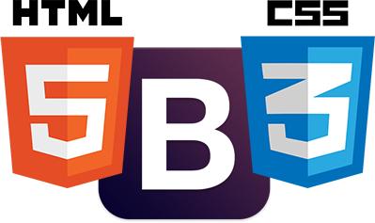
Fig 2.4: Bootstrap with HTML 5 and CSS 3

Bootstrap includes HTML5 and CSS3 based design templates for typography, forms, buttons, tables, navigation, modals, image carousels and many other, as well as optional JavaScript plugins. Bootstrap also gives the ability to easily create responsive designs. Bootstrap is known in the coding world as the front end tool-kit and developmental framework which caters to the developer and includes a seemingly endless resource to build modern web pages and applications. Later because of its attributes, ease and flexibility in designing, it has earned its place as a major framework for designing in HTML 5 and other web development interface. Bootstrap is the best option to choose from that ensures the rapidity of application development.
Advantages of Bootstrap:
- Easy to use: Anybody with just basic knowledge of HTML and CSS can start using Bootstrap.
- Responsive features: Bootstrap's responsive CSS adjusts to phones, tablets, and desktops.
- Mobile-first approach: In Bootstrap 3, mobile-first styles are part of the core framework.
- Browser compatibility: Bootstrap is compatible with all modern browsers (Chrome, Firefox, Internet Explorer, Safari, and Opera).
2.9 AJAX
AJAX is the abbreviation of Asynchronous JavaScript and XML. It is not a new programming language, but a new way to use existing standards. It is the art of exchanging data with a server, and update parts of a web page without reloading the whole page. It is a group of interrelated web development methods used on the client-side to create interactive web applications. With Ajax, web applications can send data to, and retrieve data from a server asynchronously (in the background) without interfering with the display and behavior of the existing page.
Ajax is a way of developing Web applications that combines:
- XHTML and CSS standards based presentation
- Interaction with the page through the DOM
- Data interchange with XML and XSLT
- Asynchronous data retrieval with XML HTTP Request
- JavaScript to tie it all together
The significance of using AJAX in CIMS is that it does not alters the system at the time of user using the functionalities of the system.
2.10 Adobe Photoshop
Adobe Photoshop, or simply Photoshop, is a graphics editing program developed and published by Adobe Systems. It can edit and compose raster images in multiple layers and supports different combination of colors and its models including RGB, CMYK, Lab color space, spot color and duotone. Photoshop has vast support for graphic file formats but also uses its own PSD and PSB file formats which support all the aforementioned features. In addition to raster graphics, it has limited abilities to edit or render text, vector graphics (especially through clipping path), 3D graphics and video.
It is a popular program for creating and modifying images for the web. Here, we designed the basic outlook of the web pages.
2.11 Microsoft Visio 2013
Microsoft Visio is a diagramming and vector graphics application and is part of the Microsoft Office Microsoft made Visio 2013 for Windows available in two editions: Standard and Professional. The Standard and Professional editions share the same interface.
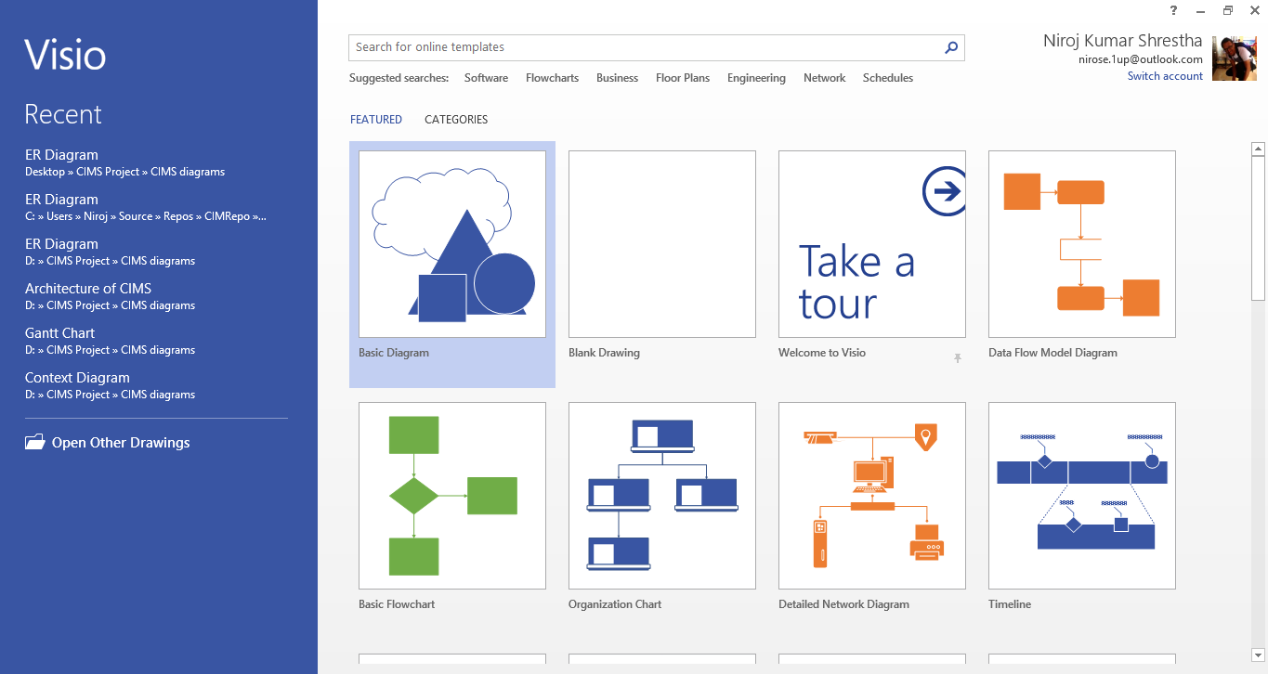
Fig 2.5: Microsoft Visio Professional 2013
We used this application to draw all system design diagrams i.e. ER diagram, Context diagram, Data flow diagrams, use-case diagram, flowchart and architecture of the system.
CHAPTER 3: SYSTEM DEVELOPMENT CONCEPT
  - Objective Definition
This chapter encloses the needs of the development of the project. The objects can simply be divided into two parts as following:
- Course Objectives
- Specific Objectives
    - Course Objectives
This objective fulfills the requirement of the syllabus of the Bachelor in Computer Engineering for final year II semester. The syllabus objectives as per the University rules are listed as following:
- To plan a complete computer programming project work.
- To perform the project work under the supervision of Instructor.
- To perform the written report and give the oral presentation.
    - Specific Objectives
The objectives of the project are listed below:
- Flowing proper information among the students, teachers and staffs.
- Creating login environment for the security of the system and for privacy
- Letting different users to mobilize the resources and assigning the subjects and routines as per group or user.
- Letting the entire user to edit their profile with privacy.
- Developing interface for publishing the result and showing mark sheet with rank.
  - Task and Activities
System Development Life Cycle is the process of developing, implementing, and retiring information systems through a multistep process from initiation, analysis, design, implementation, and maintenance to disposal. It helps in establishing a system project plan, because it gives an overall list of processes and sub-processes required for developing a system, which means that it is a combination of various activities.
SDLC includes the various steps towards the development of any system and it has various steps from problem definition to integrating and testing. Similarly, this project also passed through the systematic development life cycle with the concept of software engineering as its backbone, which can be summarized in the following steps:
    - Development and Phase Definition
Software development is carried out systematically in various phases and the phases are broadly categorized into system planning, analysis, design and implementation. Every phase has its own significance so that these steps have to be carried out in a proper way to get the good outcome and these steps are thoroughly followed during the software development process.
    - Problem Definition
Problem definition phase is the first in the system development. The concept of the project was developed after the identification of the problem. For the purpose of problem definition various people were visited and interacted with them to know the existing problem and desired solution. The information collected at this phase was the base for the tools collection.
    - System Analysis
This phase is the identification of various tasks and activities that has to be performed. It is process of developing a detailed analysis of the problem so that the developers can better understand the problem. During this phase, the system to be developed was analyzed in the scientific way for the betterment of the system development. Also various tools to be used was considered in the analysis phase. This step helps to better understand the scope, feasibility and the requirement of the system.
Its steps can be summarized as the following;
- Understanding the problem:
This is similar to the problem definition but this is detail study of the problem so the problem can be understood in a proper and depth way.
- Feasibility analysis:
This step deals with the various types of the feasibilities that are needed to be considered during the system development. Mainly there are the different types of feasibility that are needed to be considered and they are:
- Technical Feasibility
- Economic Feasibility
- Operational Feasibility
- Schedule Feasibility
- Legal Feasibility
- Strategy Feasibility
- Establishing the System Requirements:
This includes the description of the requirement of the users and the groups to whom the product has been targeted.
    - System Design
After finishing the system analysis, we did the conceptual design of the system through different diagrams such as Use-Case diagrams, Data Flow Diagrams (DFDs), ER diagram and other architecture. It is the creation of the framework that shows developers how to convert the system requirements into a workable, operational system by exploring different design and identifying the best design for the project. It is seen in the following 2 steps:
- Logical Design:
It identifies the records and relationships to be handled by a system. It focuses on the logic or the reasoning behind the system by breaking down into subsystems and the relationship among them.
- Physical Design:
It addresses the physical aspect of the system i.e., input and output devices, hardware configuration of memory networks and so on. It also defines data structure, access and file organizations.
    - System Development Coding
Once the design process has been accomplished, the system development phase was started that has the coding phase along with the coding and testing. Coding is the phase where the pure coding of the project was done according to the part that was distinguished in the design process.

    - Integrating and Testing
This phase runs parallel to the coding process where the code that has been developed is tested and the new codes are always integrated to get the system requirement. The testing runs parallel to the coding process so that this is considered as the integrated process.
    - Architecture
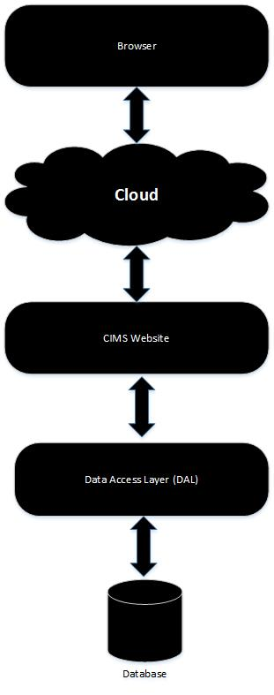
Fig 3.1: Architecture of CIMS

  - Refining the System Needs
Once the specified steps of the software engineering have been carried out in an orderly process then, the refinement in the system development can be obtained. This helps in the decision making process for the designers such as us who are still in the learning phase so that the refinement of the project can be done.
In our case, as the system to be designed requires the fine use of the database as well as decision making methods should be incorporated to generate the report. User authentication has been assigned which allows the user of the system to validate the password before entering own profile and into the system as per the permissions granted.
  - Conclusion
The development of the system either can be commercially used in the different organizations for the better improvement of the manual dependent and time-consuming work or can be used as the fulfillment of the academic purpose. To accomplish both the task, we need to go thoroughly through the systematic and proper software development phase. All the development process task should be considered while designing the system.

CHAPTER 4: FEASIBILITY STUDY AND REQUIREMENT
ANALYSIS
This chapter includes brief description of the design processes that has been incorporated during the development of the system. The feasibility study and the requirement specifications are set towards the various designs that are compatible with requirements which have been studied by us. The requirement must be focused out from the end user who is the main source of the requirement.
  - Feasibility Study
Any project that has to be developed must be feasible under certain constraints within the given resources. A feasibility studies main goal is to assess the economic viability of the proposed system or not.
‘CIMS’ is a feasible system that equally considers economic, technical, and behavioral factors. Since, the students, the teachers and the managerial staffs should be notified with some urgent and important notice or events, or should mobilize the resources with each other in individual or group basis, this system gives any time access to users anywhere wherever there is access to internet. To talk about the technical overview of the ‘CIMS’, it is technically managed and can be handled with less technical knowledge.
- Cost/Benefit Analysis:
This is another important step and that needs to be considered for the reason that whether the system that has been developed has the benefit upon the cost in the existing system or not, so that, the betterment in the implementation in the new designed system can be shown.
Since this project doesn’t require any special type of hardware to be installed so that the cost won’t go much higher than the cost of the computers and the cost of the development charge so this surely has a cost benefit. This system requires one-time investment, which may cost much but later this system only needs the updating annually. It also minimizes the cost required for the staffs as less number of staff will be enough in the college.
  - Requirement Analysis
This is the main thing that needs to be considered for the system development process. Without the system requirement specification, the system development is not feasible. The requirement analyses have been done by case study of the existing system of the cooperative and questionnaire of different people of educational institutes and colleges.
    - Scope:
//documentation
  - Requirement Attribute
    - Client:
The system is targeted to any colleges and educational institutes.
    - Target Version:
This is intended to implement the management of the college information and also to allow proper flow of information among the users. Hence, it will be upgraded according to the colleges and educational institutes requirements.
  - Requirements
    - Usability
This system has the GUI interface that gives the access to the system through the web and is easier for the user to learn since the complexity can be reduced by modern tools of the OOP. This requires the user who can just operate a computer even without extra knowledge.
    - Reliability
The software is the prototype for the requirement and it cannot fulfill the requirements that aren’t dealt with but can be further extended according to the college process and college family requirement.
    - Performance
The performance of the system is based on the bandwidth of the internet. Higher the bandwidth, better is the performance.
    - Supportability
Since the entire OOP is done with ASP.NET MVC 5 technology which is taking the global market and as is web application, it is reliable platform to use in any environment.
    - Scalability
The weight of the requirements won’t affect the performance.
    - Extensibility
It can be further enhanced to solve the problems that can occur or the problems that has not been identified currently.
  - Interfaces
This section defines the interfaces that must be supported by the application. For simplicity, the interface requirements have been categorized into three sections as follows:
    - User Interfaces:
User interfaces will be implemented as GUI. A set of customizable graphical components, whose similar look and feel emphasizes the system consistency. The User Interface for desktop and distributed applications must assure the convenience to its users.
    - Software Interfaces:
The system requires drivers for communicating with the adopted database.
    - Communications Interface:
The software should be distributed in nature capable of handling distributed databases and services. Hence, local area network and remote serial devices are required.
  - Conclusion
The project always needs to be finished within the given time constraints and the requirements that are developed and considered during the system development process need to be fulfilled. The planning that has been done before the start of the system development with the requirement should be kept into consideration during the development cycle.

CHAPTER 5: SYSTEM PLANNING AND DESIGN
This section is the brief description of the design processes that have been incorporated during the development of the system. The term design describes the final system and the process by which it is developed. It refers to the technical specifications that will be applied in implementing the candidate system. It also includes the construction of programs and program testing.
5.1 Schedule Planning
Any project that has to be developed is done under certain constraints in a fixed period and the schedule that had been developed during the system development. The following is the Gantt chart with the full timeline of our project:
5.2 System Design
System design is a solution It provides the understanding and procedural details necessary for implementing the system recommended in the feasibility study. The emphasis is made on translating the performance requirements into design specification. The design goes through logical and physical stages of development. Logical design reviews the current physical system’ prepares input and output specification’ makes edit security and control specification’ details the implementation plan; and prepares a logical design walkthrough. The physical design maps out the details of the physical system, plans the system implementation, devises a test, implements the plan, and specifies any hardware and software.
5.2.1 Application Environment Establishment
The development of the new system always requires the establishment of the environment where the system has an efficient working condition. This step always takes the operating system into considerations as well as the software package that are used for the software development process. Since ASP.NET is used as the main programming tools, which is platform independent so there is no specific operating system for running the program but following can be recommended for the program.
★ Windows all versions with .Net 4.0 framework for server
★ Any operating systems as client
5.2.2 Application Design
This is the design of the input and output sections, various process involved and the interfaces that are required for the interaction of the program with the user.
5.2.2.1 Input Design
Input design is and end-user interface that has to be analyzed very consciously, while designing a system. It is important in case of data consistency and data integrity. We have to design input screens and layout in such a way that end-user can enter data and information easily and in limited time for efficiency.

5.2.2.2 Output Design
Output design should be presented in a way that is easy to understand and interpret. Format consistency is an attribute of ‘user-friendly’ output.

5.2.2.3 Process Design
Process models show the overall process and the processes that are supported by the system. Data flow models may be used to show the processes and the flow of information form one process to another. The figures that show the process in our project are shown in the Data Flow Diagram that incorporates the process along with it. DFD graphically illustrates movement of the data between external entities and the process and data stores within a system.
a) DFD
A Data Flow Diagram (DFD) is a diagrammatic representation of the information flows within a system, showing:
★ How information enters and leaves the system.
★ What changes the information.
★ Where information is stored.
DFDs are used not only in structured system analysis and design, but also as a general process modeling tool. Having a DFD will make the end users able to visualize the operation of the system, they will see a better perspective what the system will accomplish and how the whole project will be implemented.

The context-level or level-1 data flow diagram shows the interaction between the system and external agents which act as data sources and data sinks. On the context diagram the system’s interactions with the outside world are modeled purely in terms of data flows across the system boundary. The context diagram shows the entire system as a single process. It’s boundaries by highlighting its sources its sources and destinations. Documenting the system’s boundaries by drawing a context diagram helps the analyst, helps the analyst, the user, and the responsible managers visualize alternative high-level logical system designs.
b) Flow Chart
A flow chart is a graphical or symbolic representation of a process. Each step in the process is represented by a different symbol and contains a short description of the process step. The flow chart symbols are linked together with arrows showing the process flow direction.

Figure chart……..

c) Use Case Diagram

A use case is a set of scenarios that describing an interaction between a user and a system. A use case diagram displays the relationship among actors and use cases. The two main components of a use case diagram are use cases and actors.

Diagram……..

d) ER Diagram

An entity-relationship (ER) diagram is a specialized graphic that illustrates the interrelationships between entities in a database. ER diagrams often use symbols to represent three different types of information. Boxes are commonly used to represent entities. Diamonds are normally used to represent relationships and ovals are used to represent attributes.

ER diagram is an abstract and conceptual representation of data. Entry-relationship modeling is a database modeling method, used to produce a type of conceptual schema or semantic data model of a system, often a relational database, and its requirements in a top-down fashion. Diagrams created by this process are called entity-relationship diagrams, ER diagrams, or ERDs. The building blocks of ER Diagram are entity, attribute and relationships.

5.2.2.4 Interface Design

The interface design in another important aspect that needs to considered during the program development because the interface is the main user interaction section that the user of the program uses for their convenience purpose of the data entry and the handling of the software.

5.3 Class Diagram Design

……………………………….
…………………………………..

5.4 Module Level Design

While designing modules, “Co-operative Management System” has been considered as having independent module concept. Any module has no dependency with data of programming and configuration along with database system. This concept reduces the error raise on transit period of switch in modules and running modules independently.

5.5 Conclusion

Hence the development of the system always starts with the establishment of the environment system that shows the operating system require and the system considered for the development and running of the system. Different object Oriented Programming tools have been incorporated during the accomplishment of this project that eased the project development to greater extent.

6.1 Website Development

A website may be the work of an individual, a business or other organization and typically dedicated to some particular or organizational topic and purpose, any website can contain a hyperlink to any other website.

A website is hosted on a computer system known as a web server, also called HTTP server and these terms can refer to the software that runs on these systems and that retrieves and delivers the Web Pages in response to request from the website users.

A dynamic website is one that has frequently changing information or interacts with the user from various methods or direct interaction. There is a wide range of software systems such as Active Server Pages, Java Server Pages and PHP programming language that are available to generate dynamic web systems and dynamic sites. Sites may also include content that is retrieved from one or more databases or by using XML-based technology such as RSS.

In our project, we have used Active server Page (APS.NET) and SQL Server. We have used C# as programming language for styling, we have used Cascading style Sheet (CSS).

6.2 Web Server/Clients

A web server houses web objects, each addressed by a URL. Web servers also implement the server side of HTTP. A web server typically contains documents that it servers to its client. These documents are called web pages. A web page consists of objects. An object is simply a file such as HTML, File, JPRG image, GIF image, a Flash document, an audio clip and so on-that is addressable by a single URL.

Most web pages consist of a base HML file and several referenced objects. For example, if a web page contains HTML text and five JPEG images then the web page contains six objects. The base HTML file references the other objects in the page with the object’s URLs. Popular web servers include Apache and Microsoft IIS.

A browser is a user agent for the web. It displays the requested web page and provides numerous navigational and configuration features. Web browsers also implement the client the client side HTTP. Thus, in the context of the web, the term ‘Browser’ and ‘Client’ are interchangeably used. Popular web browsers include Netscape Communicator, Microsoft Internet Explorer, Mozilla fire Fox, Google Chrome, etc.

6.3 Tools Used

For accomplishing the system development different tools are uses:
1. Microsoft Visual Studio 2008
2. NET Framework
3. ASP.NET
4. SQL Server
5. C# Programming language
6. Cascading Style Sheets (CSS)
7. JavaScript
8. Ajax
9. Adobe Photoshop

6.4 System Maintenance

System maintenance is the enigma of system development. It holds the industry captive trying up programming resources. System maintenance follows the conversion to the extent that changes are necessary to maintain satisfactory operation relative to changes in the users’ environment. Maintenance often includes minor enhancements for corrections to problems that surface late in the system’s operation. Analyst and programmer spend far more time maintaining program that they do writing them. Maintenance accounts for 50-80 percent of the total system development.

Maintenance can be classified as corrective, adaptive or perfective. Corrective maintenance means repairing processes or performance failures or making changes because of previously uncorrected problems or false assumption. Adaptive maintenance means changing the program function. Perfective maintenance means enhancing the performance or modifying the programs to response to user’s additional needs.

6.5 Conclusion

Thus for the project development process, various software and platform are needed and that requirements are fulfill using the most reliable and the happening software in the world’s market. The different technologies such as, Ajax has also been incorporated.

7 SYSTEM TESTING

System testing is the process of testing the software that has been developed by the process that gone through analysis, design a development. It includes well-defined steps result in the successful construction of the software. A software testing strategy should be flexible enough to promote a customized approach. At the same time, it must be rigid enough to promote reasonable planning and management tracking as the project progresses.

7.1 White Box Testing

White box testing is a text case design method that uses the control structure of the procedural design to derive test cases. White box testing of software is predicted on close examination of procedural details. Logical paths through the software are tested by providing test cases that exercise specific set of conditions and loops. White box testing focuses on the program control structures.

The programmer and designer test the logic of the modules of program. Through this testing the execution of each and every statement and checking condition of all decision paths within the logic of individual modules are found to be perfectly working with only few exceptions. Control and data flow was clear. From this test, we derived at the following test cases:

★ Guarantee that all independent paths within the module have been exercised at least once.
★ Exercise all logical decisions on their true and false sides.
★ Exercise all loops at their boundaries and within their operational bounds.

7.2 Black Box Testing

Black box testing focuses on the functional requirements of the software. It is a user acceptance testing that has the objective of telling on the validity and the reliability of the system.

Black box testing is not an alternative to white box testing rather it is a complementary approach that is likely to uncover different class of error than white box testing. This black box testing, also called the behavioral testing ensured the functional requirements of the software. From this test, we derived at the following test cases:

★ Incorrect or missing functions.
★ Interface errors.
★ Errors in dare structures or external data base access.
★ Behavior or performance errors.
★ Initialization and termination errors.

7.3 Conclusion

Thus, after all the testing we are able to correct the errors and small mistakes that had previously been unseen and thus, we can improvise and/or figure out some other way to carry out tasks that had been troubling.

8. IMPLEMENTATION

A crucial phase in the system’s life cycle is the successful implementation of the new system design. Implementation simply means converting a new system design into operation. A critical factor in conversion is not disrupting the functioning of an organization. In system implementation, a ‘help’ screen can provide a good start on the system.

8.1 System Evaluation

Every system requires periodic evaluation after implementation. A post-implementation review measures the system testing, which determines where the system fails so that the necessary adjustments can be made a post-implementation review determines how well the system continues to meet the performance specifications. It is the fact-after design and conversions are complete. It also provides information to determine whether major redesign is necessary.

8.2 Support

The software will undoubtedly undergo change after it is delivered to the customer. Change will occur because errors have been encountered, because the software must be adopted to accommodate changes in its external environment, or because the customer require functional or performance enhancements, Software support/maintenance reapplies each of the preceding phases to and existing program rather than the new one.

8.3 Conclusion

Hence, the successful implementation was possible without any hindrance. However, the software will be changed later to catch up with the demand of the users and ease.

CHAPTER 9: LIMITATIONS AND FUTURE ENHANCEMENT
As no machine is 100% efficient likewise no task or project is ever performed without limitations. Similarly, our project also moved to many obstacles even critical situations were faced which compelled us to leave some limitations. The following are the limitations of our project:

CHAPTER 11: REFERENCES
- https://www.codecademy.com/courses/web-beginner-en-yjvdd/0/1/2015-Oct-28/10:25am
- http://www.asp.net/mvc/overview/older-versions-1/overview/asp-net-mvc-overview/2015-Oct-30/5:40pm
- http://ajax.net-tutorials.com/controls/updatepanel-control/2015-Nov-1/12:40pm
- http://www.w3schools.com/aspnet/mvc_intro.asp/2015-Nov-6/3:35pm
- http://www.drdobbs.com/tools/microsoft-visual-studio-2013-review/240163830/2015-Nov-11/3:55pm
- http://www.tutorialspoint.com/bootstrap/2015-Nov-11/4:15pm

Appendix
List of figures of your project output with each Figure No. and Title.
(These should also be included in List of Figures in the beginning.)

